SIEMENS DustSensor Software(V2.0) Instruction Manual
Environmental construction
- A RaspberryPi with raspbian-wheezy system, Download from https://www.raspberrypi.org/downloads/raspbian/ ;
- Enable the UART port:
Modify two files
[1] /boot/cmdline.txt
[Enter the following command]
sudo vi /boot/cmdline.txt
[Delete the red part]
dwc_otg.lpm_enable = 0 console = ttyAMA0,115200 kgdboc = ttyAMA0,115200 console = tty1 root = /dev/mmcblk0p2 rootfstype = ext4 elevator = deadline rootwait
[Eventually become]
dwc_otg.lpm_enable = 0 console = tty1 root = /dev/mmcblk0p2 rootfstype = ext4 elevator = deadline rootwait
[2] /etc /inittab
[Enter the following command]
sudo vi /etc/inittab
[Note the last line]
# T0: 23: respawn: / sbin / getty -L ttyAMA0 115200 vt100
- Install git:
[Enter the following command]
sudo apt-get install git
- Enter into the directory named pi;
get the code:
[Enter the following command]
git clone https://github.com/mxinchiang/DustSensor.git
- Use makefile to compile;
- Install ftp, This is necessary to achieve file transfer:
[Enter the following command]
sudo apt-get install vsftpd
- Create a new directory named TestFile in the folder pi to store log files:
[Enter the following command]
cd /home/pi
mkdir TestFile
- Configuration crontab:
[Enter the following command]
sudo crontab –e
[Add the contents in the final of the file]
*/1 * * * * /bin/bash /home/pi/DustSensor/monitor.sh >/home/pi/DustSensor/log_se.txt 2>&1
*/1 * * * * /bin/bash /home/pi/DustSensor/network-monitor.sh >/home/pi/DustSensor/log_net.txt 2>&1

Program list on raspberrypi:
server.c
se_socket.c
conn_pi.c
msg_decoder.c
se_socket.h
conn_pi.h
msg_decoder.h
makefile
monitor.sh
network-monitor.sh

server.c
Server-side program's main entrance, Including a function call creates socket and a function call connection Raspberry Pi.
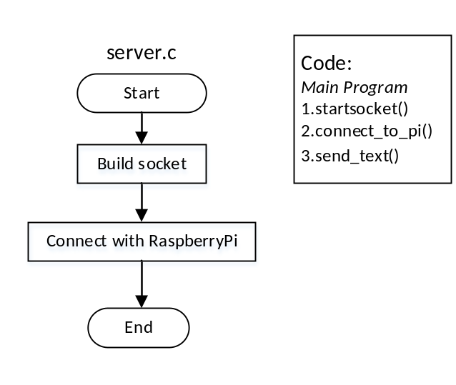
Fig 1. server.c flow chart

se_socket.c
Functions
void *build_socket(void *arg)
Create sockets for server, first create a new Socket with the defined family, type and protocol. Then bind to a local address before you can receive connections, marks the socket as a server socket to listen and waiting the client to connect, a socket that is used to accept incoming requests using accept(). Then create a thread for communication.
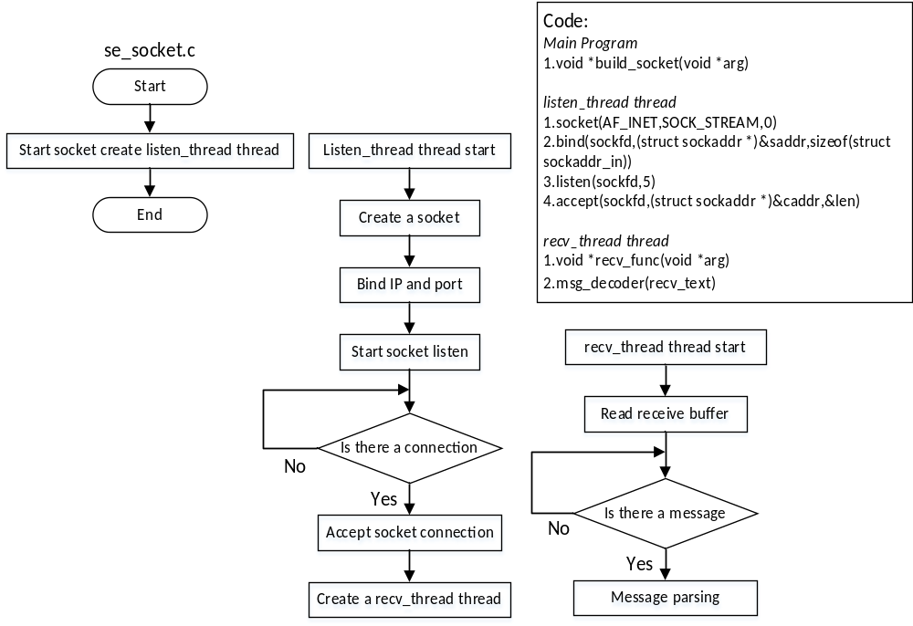 Fig 2. se_socket.c flow chart

void *recv_func(void *arg)
To Receive message from client

void send_func(const char * send_text)
Tries to send size bytes from buffer on the socket. This is mainly used by connection-oriented sockets.
Parameters
send_text a string containing message you want to send

void send_text()
Use scanf to record the message you want to send

void startsocket(void)
The main entrance of socket function. It is be used in other place where should enable the socket function.

conn_pi.c
Function
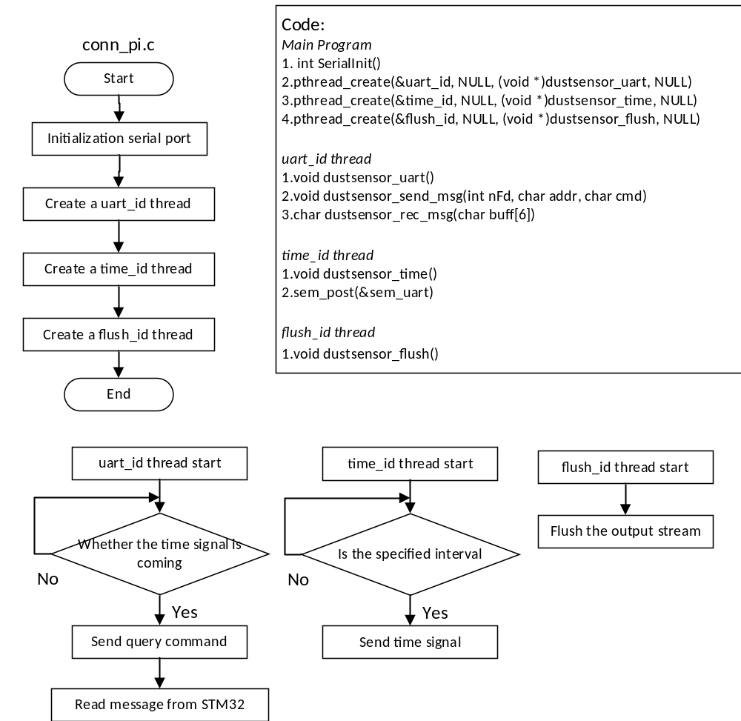 Fig 3. conn_pi.c flow chart

int SerialInit()
Set the basic properties of the serial port, The operation of the Linux is equivalent to the operation of the file.

void dustsensor_send_msg(int nFd, char addr, char cmd)
Message sending function
Parameters
nFd Device identifier
addr Device address
cmd Command

char dustsensor_rec_msg(char buff[6])
Method for receiving messages. Thread calling.
Parameters
buff[6] a string containing message you received from the pi.

void dustsensor_uart()
UART using function, using uart to send message and receive message. Calling dustsensor_send_msg and dustsensor_rec_msg.

void dustsensor_time()
Time signal generator, Time signal used to generate a certain frequency interval. To control the sending frequency of the sampling command.

void dustsensor_flush()
Flush the output stream.

int connect_to_pi()
The main entrance of connecting RaspberryPi function. It is be used in other place where should enable the pi function.

msg_decoder.c
Function
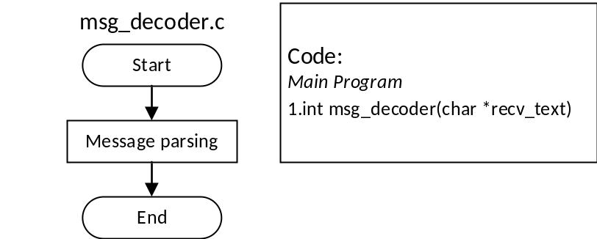
Fig 4. Msg_decoder.c flow chart

int msg_decoder(char *recv_text)
Analytical control instruction, as the parameter of this function the message sent from the client was resolve by it.
Parameters
recv_text a string containing message you received from the client.

The automatic restart process with the help of the planning task(cron) is the purpose of these Shell Script.
monitor.sh
Function
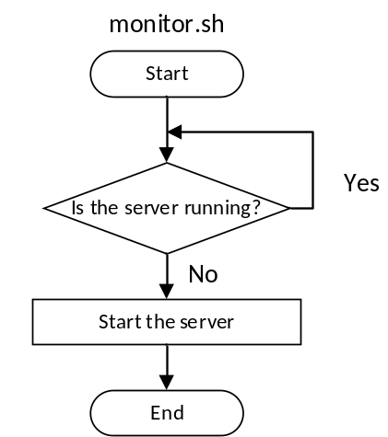
Fig 5-1. monitor.sh flow chart

network-monitor.sh
Function
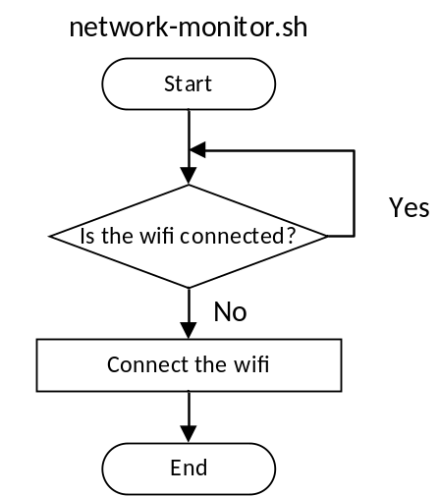
Fig 5-2. network-monitor.sh flow chart

To use these scripts we need to configure the Cron, use “sudo crontab -e” to edit the configuration of crontab.
At the end of the file, add the following two lines:
*/1 * * * * /bin/bash /home/pi/DustSensor/monitor.sh >/home/pi/DustSensor/log_se.txt 2>&1
*/1 * * * * /bin/bash /home/pi/DustSensor/network-monitor.sh >/home/pi/DustSensor/log_net.txt 2>&1
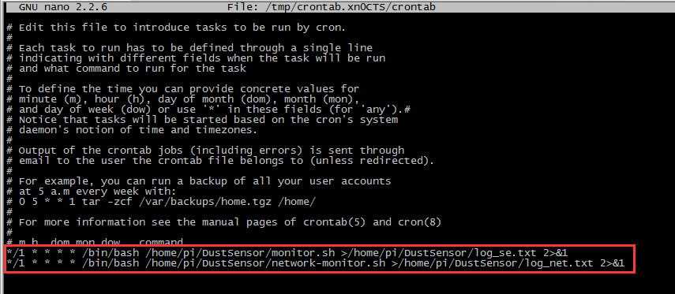
Fig 5-3. the configuration of crontab
Format description:
# m h dom mon dow command
# * * * * * command to execute
# ┬ ┬ ┬ ┬ ┬
# │ │ │ │ └───── from 0 to 6 on Sunday to Saturday, 7 is Sunday, equivalent to 0)
# │ │ │ └────────── month(1 - 12)
# │ │ └─────────────── day (1 - 31)
# │ └──────────────────── hour (0 - 23)
# └───────────────────────── minute(0 - 59)

Program list on PC:
MainWindow.xaml
MainWindow.xaml.cs

MainWindow.xaml.cs
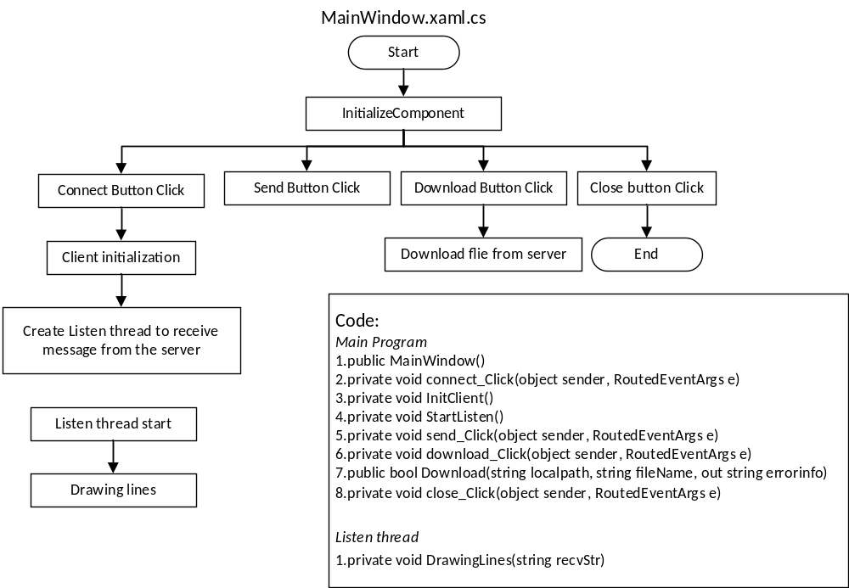Fig 6. MainWindow.xaml.cs flow chart

public partial class MainWindow : Window
Major classes for the project.

public MainWindow()
Constructor without parameters. Contains the initialization of the control and the image source definition.

private void InitClient()
Socket client initialization, and the reception of the message thread begin.

private void DrawingLines(string recvStr)
Method of drawing the waveform chart using DynamicDataDisplay.
Parameters
recvStr a string containing message you received from the server.

private void StartListen()
Socket method for receiving messages. Thread calling.

private void connect_Click(object sender, RoutedEventArgs e)
Initialize socket client to connect the server

private void send_Click(object sender, RoutedEventArgs e)
Send message to server, to change the frequency of the sampling

private void download_Click(object sender, RoutedEventArgs e)
Using class FtpUpDown to achieve download function

private void close_Click(object sender, RoutedEventArgs e)
Program closing button

public class FtpUpDown
Implements a File Transfer Protocol (FTP) client. Retrieves the stream used to upload data to an FTP server. FTP document download.

